Connecting Curriculum And Context:
The Foundations for Relevance in Theological Education
Rupen Das

This paper was presented at a plenary session at ICETE C-15 in Antalya, Turkey on 7th Nov. 2015.
The relevance of theological curriculum to specific contexts has always been a challenge. However, in a pluralistic world with greatly varying contexts and cultures where graduates are ministering, theological education has to be context sensitive and relevant. It is no longer enough to ensure that students have mastered a core of theological concepts and truths, have biblical knowledge, and some basic ministry skills. The impact of a theological institution is thus measured by the effectiveness of their graduates in their specific ministry context(s). Therefore the theological curriculum has to be connected with the context(s) of the graduates. This paper explores historical models that have responded to needs within the church and in society, and then asks how theological institutions today can intentionally be relevant to context.

Introduction

Today as we meet in Antalya, it is very appropriate that we are here discussing the relevance and impact of theological education, in a part of the world where the issue of being faithful to the teachings of the Apostles in a context of competing philosophies and allegiances, was a significant challenge for the very Early Church. The question was, how was the truth about Christ communicated in contexts that were very different from the Jewish world where the Apostles had known Christ. The issue was one of connecting the teachings of Jesus and the Apostles with context.

This challenge was probably most clearly seen in the life of Polycarp, whose family had moved from Jerusalem after its fall in 70 AD and had settled in the province of Asia, a few hundred kms west of here. It was here as a young man, in the city of Ephesus that he was discipled by the Apostle John. Polycarp, was later appointed by John himself as the Bishop of Smyrna, present day Izmir, further up the coast from here.

The importance of Polycarp is that he was one of the few Church Fathers who were a direct link between the Apostles, who had known Jesus and heard His teachings, and the Early Church of the late 1st century and early 2nd century. At a time before the young church’s doctrines had been crystalized through the various Councils and Creeds, the challenge for Polycarp was to ensure that the teachings of the Apostles that he had heard directly from John remained unadulterated and were passed on to the next generation.

This was no easy task. At a time when Hellenism was on the rise and a Greek worldview dominated any intelligent discourse, the Apostle John had been able to contextualize the understanding of who Christ is by adopting the term Logos from Greek philosophy to try and explain how God is involved in the world and in human life. Observing John’s effort at contextualization, Polycarp had not only learnt the doctrines that were beginning to define this new faith, but he also learnt how to connect the reality of Christ whom he had come to know, with the cultural and intellectual context in which he lived.

This proved critical when he was confronted with the heretic Marcion, who tried to separate the church from its Jewish roots and in the process redefine who Jesus and God were. In order to deal with the heresy, Polycarp was able to sift through the arguments from Greek culture and philosophy that undergirded Marcion’s heresy and did not align with the Truth, in the process ensuring that the Early Church remained rooted in the teachings of Jesus and the Apostles.

This then is the challenge that all theologians and missiologists face – how does one take Truth learnt in one context and make it relevant in another? Princeton theologian Daniel Migliore writes, “Confession of Jesus Christ takes place in particular historical and cultural contexts. Our response to the questions of who we say Jesus Christ is and how he helps us is shaped in important ways by the particular context in which these questions arise”. For theological educators, the challenge is even more complex – how does one teach students the skills to take the Christ they know in their context and enable people in a different historical and cultural context to encounter Jesus Christ. This is exactly what the Apostle John had to do, to take the Christ whom he had known in a Jewish Palestinian context and teach Polycarp in an intellectually Greek and politically Roman context of how to proclaim Christ. In a sense, the Apostle John’s effectiveness in discipling and training Polycarp can be assessed by the success with which Polycarp handled the Marcion heresy.

Assessment of the impact of theological education has always been a challenge. What we are looking at this morning is how do we connect the theological education we provide with the contexts where our students will be ministering in order for them to be effective. In a pluralistic world with greatly varying contexts and cultures where our graduates are ministering, theological education has to be context sensitive and relevant. It is no longer enough to ensure that students have mastered a core of theological concepts and truths, have biblical knowledge, and some basic ministry skills. The impact of a theological institution is measured by the effectiveness of their graduates in their specific ministry contexts. Therefore theological curriculum has to be connected with the contexts of the graduates.
Pastor and theologian Eugene Peterson states that all ministry is rooted in geography. He writes, “Now is the time to rediscover the meaning of the local, and in terms of church, the parish. All churches are local. All pastoral work takes place geographically.” If this is true, then do the graduates have the ability and the tools to understand the local context?

Others at this conference will be looking at how does one assess the effectiveness of theological education and its impact? This morning I will try and lay some foundations for that discussion by 1) looking at how different models of theological education over time evolved to respond to needs within the church and in society, and 2) how does a theological institution intentionally connect with its context? I will present a model of how that is done.

Models of Theological Education

There is no one model of theological education. Since the time of the Early Church to the present, the type of theological education that was available was based on 1) the needs of the church in a particular context, as well as 2) on the influence of the local culture.

There are three commonly accepted models of theological education. The original thinking was developed by David Kelsey of Yale Divinity School describing a classical versus a vocational approach. To this was added Robert Bank’s missional approach.

The classical model, sometimes referred to as “Athens”, defined theological education as Christian character formation or paideia. It was derived from classical Greek educational methodology and literally means child rearing or education, and is a process of moulding character. The objective was to produce well-rounded and fully educated citizens. The concept of paideia does not start with the individual person and their potential but with the concept of the ideal person. So the process of education was to educate and mould human beings into the ideal man who represented human nature in its truest form. Greek and Roman philosophers, artists, sculptors, educators and poets drew their inspiration from the concept of an ideal man. The goal of classical education was the transformation of the individual.

The Early Church adopted and then adapted this model. Some of the Church Fathers saw the Christian faith as a form of paideia, that in order to grow in one’s faith, one’s character had to be formed. By the medieval and monastic period it had become the dominant educational philosophy. Paideia influenced Basil of Caesarea in the development of his monastic rules. The objective was to enable individuals to develop a holistic vision that understands and grasps the totality of life, including the world. Rather than just knowing about God, the focus was on knowing God.

Brian Edgar at Asbury Theological Seminary writes, “It is not about theology, that is, the formal study of the knowledge of God, but it is more about what Kelsey calls theologia, that is gaining the wisdom of God.” The emphasis was on holiness and the transformation of the individual. Edgar states that in this model of theological education, holiness, and moral and spiritual transformation are central.

The vocational model, referred to as “Berlin” and with its roots in the Enlightenment, sees theological education as being a preparation for a professional Christian vocation and therefore needed to be situated within the context of a university as an academic discipline. The term wissenschaft is a German term that means a study or science that requires systematic research. The origin of wissenschaft as a model for seminaries is Friedrich Schleiermacher’s pioneering work at Humboldt University in Berlin. The goal was no longer the moral and personal formation of individuals through the study of authoritative texts, but in training students in rigorous enquiry in order to move from theory to practical applications.

Schleiermacher’s task was to design a curriculum that would train professional ministers for the State Church in Germany, within the context of defending theology’s status as an academic discipline. He built on the fourfold structure of traditional theological curriculum from the period of the Reformation that was used to train pastors and teachers. This consisted of Biblical Studies, Church History, Dogmatics or Systematic Theology, and Practical Theology. He adapted it to a modern university context. Schleiermacher’s argument was that the university had a mandate to train clergymen; their training was no different than that of practioners of medicine and law. In all three disciplines there was a progression from theory to professional practice. Adopting this model of study was at the loss of paideia and personal, moral and spiritual formation.

Schleiermacher’s model is still very much the framework that is used in most theological training today, though the specific content of the four areas of study may have changed. There is an understanding that both knowledge and skills are needed for pastoral ministry. Many Evangelical seminaries incorporate elements of both the classical and vocational models in their curriculum. There is an emphasis on character formation and the moulding of worldview, as well as the “professional studies” required to be a pastor or in some kind of Christian ministry, though the emphasis is more on the theory and knowledge.

The last commonly accepted model, the missional model, was developed by Robert Banks, at Macquarie University in Sydney, and is referred to as “Jerusalem.” The missional model sees mission encompassing all aspects of life – family, friendships, work and neighbourhood. For Banks, mission is not just being mission oriented but “an education undertaken with a view to what God is doing in the world, considered from a global perspective.” Therefore theological education is not an independent discipline but is seen as part of mission. The objective was to be involved in missio Dei – the mission of God. It’s a model that provides a connection between action and reflection. For Banks the best theological education and spiritual formation is partly field-based, stretches students to do what they are studying, encompasses all of life, and addresses mission opportunities.

The thinking on the three categories has been further developed to incorporate other models of theological education. Brian Edgar, professor at Asbury Theological Seminary, adds a fourth model called the confessional model. Referred to as “Geneva,” the goal of theological education is to know God through the means of grace and the traditions in a particular faith community, and more specifically through the creed and confession of that community. This involves “formation…through in-formation about the tradition and en-culturation with it.” This is done through teaching about the founders, the heroes, the struggles, the strengths, and the traditions that are both distinctive and formative for that community. Examples of this are denominational affiliated seminaries and training institutions of specific mission agencies.

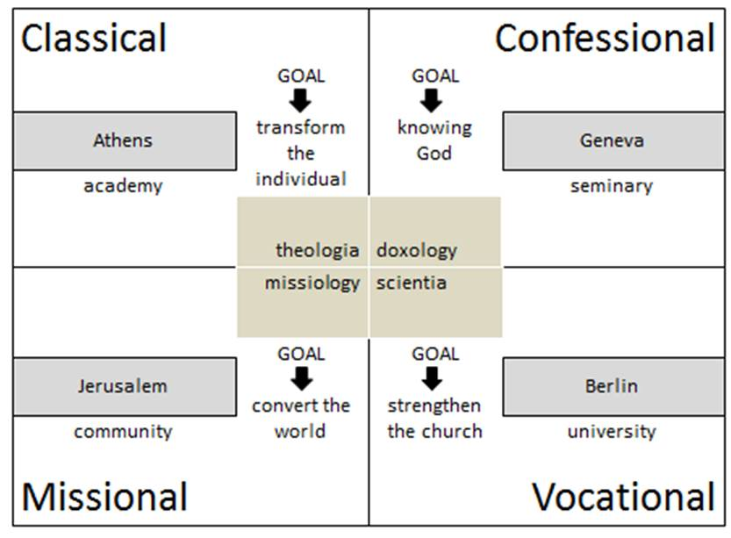
Figure 1. Four Models of Theological Education

Darren Cronshaw, mission researcher at the Baptist Union of Victoria in Australia, adds two further models. The first is the contextual model and referred to as “Auburn.” According to Cronshaw, theology and mission needs to be expressed in specific contexts such as those in his local neighbourhood of Auburn. So theological training for the contextual model deals with understanding local context and learning how to build community (koinonia). It is this community that lives out the Gospel and in the process the boundaries dissolve. Together they experience community and demonstrate the love of God so that others may belong, and one day believe.

The final model that Cronshaw adds is the spiritual model, also known as “New Delhi.” This is a model for a multicultural and pluralistic world. Cronshaw writes,

A New Delhi context for missional spirituality is the ashram. As the balance of global power and Christian influence is shifting to the global South, Kraig Klaudt artfully suggests that certain Indian ashrams feature helpful characteristics that theological education can adopt. These ashrams are located “in the world” without fences; are open to all; offer community living that is engaged in service; emphasize simple living and spiritual maturity more than publishing; provide a holistic curriculum of intellectual, spiritual, political, aesthetic and relational development; and create time and space for spirituality and self-awareness. Locating theological education and missional spirituality in New Delhi reminds me to engage with the worldviews of my neighbours and to welcome the alternative model of the ashram.

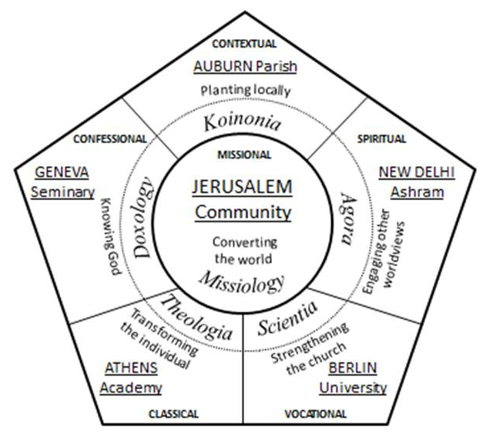
Figure 2. Six Models of Theological Education and Missional Spirituality

Each of these models understood their role in theological formation differently, and as a result defined impact differently. While there is great value in each of these models, and certain elements of each model can be transferred across cultures and contexts, each of these six models of theological education responded to specific needs in the church and in society.

These six models also highlight the variety of theological education that is available today. There is theological training for laity, for training in ministerial theology, in professional theology and in academic theology. Each requires a different curriculum and has different goals. Theological institutions need to be clear as to what they hope to accomplish and this will determine the model of theological training that they use.
Connecting Curriculum to Context

While different models of theological education are a result of specific needs of the church at a point in time in history, or in a specific location, how does a theological institution today intentionally connect with its context? How does one connect curriculum with context so that the graduates are effective?

The basic principle is that education is for a purpose. So a theological institution does not exist to produce graduates, but to meet needs in churches, the mission field and in Christian organizations. It does so through it’s graduates. So the effectiveness of a theological institution is then assessed not by how many graduates it produced and the quality of the graduates but whether the graduates were able to meet the needs of churches, mission agencies and the communities where these graduates work. Was its curriculum relevant to the context of the graduates?

This principle of “education for a purpose” is illustrated through what is referred to as a program logic. What this means is that an activity produces a result. There is a cause and effect relationship. In education, this means that teaching results in learning. We then assess whether learning has taken place through exams, research and reflection papers, case studies, simulations, field practice and a variety of other assessment tools.

There is a difference between a training activity and the result of the activity. The objective is not to report how many attended the training activity but on what changed as a result of the activity. I think most seminaries understand this well and are able to assess whether learning has taken place.

However the assessment of the training activity does not end with determining whether learning took place. If education is for a purpose, then what did the graduate do with what they learnt?

Theological institutions like any other educational institution exist within a context. There are two models of organizational theory. One is a systems theory of organizations. An organization has a structure, clearly defined roles, processes and procedures, a product (in this case a curriculum) and so on. The more clearly defined these are, the more effective the organization is. So the quality of the institution is measured by its systems and procedures, and the resources it has in terms of curriculum, faculty, facilities, library and so on. You will hear terms like ISO 9000. A lot of our accreditation is based on this theory of organizations. While context is sometimes acknowledged, a systems theory of organizations is mostly internally focused.

Others see an organization as a living system - an organism. They move away from a mechanistic model of institutions to a more biological model. Organizations are open systems. It has a structure, but it survives and is able to thrive if it is able to adapt to changes in its context and environment. The open systems approach requires organizational structure, systems and procedures to be flexible, responsive and adaptable. Such organizations are sensitive to context and are externally focused.

Both understandings of organizations are needed for quality and effectiveness of a theological institution. There is a need for both an internal focus and an external focus.

Pulling these ideas together, we get what is referred to as a program logic for an theological institution.

Figure 3. Program Logic

An activity, training provided by a seminary, results in changes in an individual. These changes are referred to as the Output.

This changed individual – the graduate – is then able to effectively minister in a church, a mission field or a Christian organization. The effectiveness of the graduate and the changes that occur in the church or the mission field as a result is called the Outcome. Note that this is different than what we often refer to as educational outcomes.

Finally, the local church or the community of believers has an influence on the surrounding community, and this is referred to as the Impact.

There is a cause and effect relationship between the activity all the way to impact. We also need to be aware that a lot of other factors can affect and disrupt the cause and effect process. These external and internal factors are known as risks and are identified and addressed if and when possible.

There are a number of implications of this:

- The focus of the theological institution needs to be at the Outcome level and not on the Output. The graduate and their training is only a means to an end.
- The theological institution’s effectiveness is measured by the effectiveness of its graduates in the contexts where they minister.
- This means that the context of the graduates needs to be understood and as a result needs to influence the curriculum of the theological institution.
So how does one then connect the context of the graduates with the curriculum of the theological institution?

To be able to connect curriculum with context, there are two organizational processes that are critical in order to ensure effectiveness of the seminary. The first is that there need to be administrative mechanisms that ensure feedback is collected at various points in the process. The second is that there need to be clear administrative mechanisms for decisions to be made based on the feedback and information that has been gathered.

- Feedback Mechanisms – An education institution needs to have feedback mechanisms to assess progress and quality of the programs. An exam, for example, assesses the progress of the student. A student evaluation of a course provides some information about the effectiveness of the faculty. A monthly financial report provides a snapshot in time of the financial status of the organization. So there need to be mechanisms at the activity, output and outcome levels that gather information and provide feedback on progress and changes taking place. While most institutions have internal feedback mechanisms, very few have mechanisms to get feedback from their external context on a regular basis.

- Decision Making – Good decisions are made on the basis of accurate information and feedback from various parts of the organization. It is not uncommon for information to be gathered and not be used. For example, when a curriculum revision is being done, are the student and faculty evaluations of the courses looked at? Is feedback gotten from graduates and the churches and mission agencies where they are working? Feedback from assessments, student and faculty evaluations, student performance need to be directed to specific educational administrators who have the ability to make the decisions regarding redesign of the curriculum or revision of specific courses. Too often evaluations are done, but the information is never used to make the educational program more relevant.

A feedback mechanism for a seminary could look like the following.

Figure 4 Organizational Assessments and Feedback Loops

A number of key points about feedback mechanisms from the diagram:

- As each activity/course is conducted and then completed, the effectiveness of the activity needs to be assessed. This is done through faculty assessments of the courses, student assessments of the curriculum, and student evaluations of the faculty.

- The seminary’s main function is to train and equip leaders. The Output, then, is that leaders are properly and adequately equipped. This is the easiest level of assessment. Most seminaries have already established Graduate Profiles or Graduation Requirements for every program that it runs. Throughout their tenure at a seminary, students are continually being assessed as to whether they are in the process of fulfilling the Graduation Requirements. This is done through tests, exams, assignments, projects, case studies and so on. The changes in the student’s knowledge, attitudes and behaviour/skills are what is being assessed.

- Any seminary’s mission should never be to only equip leaders. Equipped leaders need to serve. A seminary’s mission should be to serve the Church and mission agencies involved in the Great Commission and the Great Commandment, and they do that by equipping leaders. Measuring the Outcome, therefore, is done by assessing whether the churches and mission organizations are being served by its graduates. The right tools are needed to answer this question and the assessment needs to be done by working closely with the churches and ministry contexts where the graduates are serving.

At the Outcome level, periodic assessments of ministry contexts of the graduates (churches and/or communities) would provide a wealth of information for the redesign of the curriculum or revision of specific courses. Feedback from the graduates, the church community, key Christian leaders, as well as the community, will provide information for the revision of the three aspects of theological education:

- Basic/Core Theological Truths – These would include the Creeds, Systematic or Biblical Theology, and Historical Theology. While all theological concepts are important for any theological education, are specific theological concepts problematic in particular contexts. Students need to not only know what these are, but also understand how to address them.

- Contextual Theology – How is God perceived and understood in a particular context or culture? The issue of Christian ethics in various contexts is critical. What are Biblical perspectives on the issues of poverty and social justice, gender, race, human trafficking, immigrants, female genital mutilation and so on? What are specific social and ethical issues in a particular context that need to be addressed from within a Christian ethical framework? How is respect shown, and thus God worshiped, in a specific culture and context?

- Pastoral Theology – Are individuals and families struggling with specific issues that a graduate would know how to address? There are cultural variations on issues such as child raising and child discipline, husband-wife relationships and divorce, issues with in-laws in extended family situations, gender roles, selection of marriage partners, etc. Pastoral issues may also encompass problems related with recent converts such as persecution, baptism, being cut off from their family and community, polygamy, and so on.

These feedback loops then connect curriculum to the context of the theological institution and to that of the graduates. By connecting curriculum to context it increases the probability of the effectiveness of the graduates in the churches and mission fields they minister in. You can hear more about how this model is being used in a pilot project that OCI has been conducting with 10 seminaries from across the world in various workshops during this conference.

A program logic – such as going from the activity of theological training, to ensuring the output is as per the graduate profile, to thus ensuring the outcome of enabling the graduates to be effective in their ministry contexts, is the model that begins to ensure that theological education can have an impact.

Conclusion

To conclude – If all ministry, as Eugene Peterson says, is geographical – meaning located geographically in a specific cultural, political and historical reality, then do theological institutions understand the realities and contexts of graduates and prepare them accordingly – do they intentionally connect their curriculum to their context?

Some of you may be thinking that this is basic educational theory and after all, isn’t this the way much of education should be. American writer and philosopher Walker Percy in describing his art writes, “…you are telling the reader or listener or the viewer something he already knows but which he doesn’t quite know that he knows, so that in the act of communication he experiences a recognition, a feeling that he has been there before, a shock of recognition.” My prayer is that there have been some “aha” moments – moments of recognition for you.

To end, I would like to go back to the life of Polycarp. We have talked much about effectiveness of the graduates in the contexts where they minister. In the life of Polycarp there is another quality that the Apostle John ensured was built into his disciple – that of faithfulness, in the midst of the context.

While Polycarp was effective in safeguarding the faith by countering the heresies of Marcion, when confronted by the theology of the Roman Empire and its worship of Caesar, there was no way to counter it other than to remain faithful. Polycarp was martyred because he would not proclaim that Caesar was lord. As he faced execution by burning, he declared, “86 years have I have served him, and he has done me no wrong. How can I blaspheme my King and my Savior?”

Effectiveness and faithfulness – the two indicators that show that curriculum is connected to context.

Bibliography

Banks, Robert. Reenvisioning Theological Education. Grand Rapid, MI: Eerdmans, 1999.

Cronshaw, Darren. “Reenvisioning Theological Education and Missional Spirituality.” Journal of Adult Theological Education 9, no. 1 (2012): 9-27.

Edgar, Brian. “The Theology of Theological Education.” Evangelical Review of Theology 29, no. 3 (2005): 208-217.

Franke, John. The Character of Theology: An Introduction to Its Nature, Task, and Purpose. Grand Rapids, MI: Baker Academic, 2005.

Jaeger, Werner. Early Christianity and Greek paideia. Cambridge, MA: Harvard University Press, 1961.

Kelsey, David H. Between Athens and Berlin: The Theological Debate. Grand Rapids, MI: Eerdmans, 1993.

Migliore, Daniel. Faith Seeking Understanding: An Introduction to Christian Theology. Grand Rapid, MI: William B. Eerdmans Publishing Company, 2004.

Murray, Stuart. Church After Christendom. Bletchley, UK: Paternoster, 2005.

Peterson, Eugene. Under the Unpredictable Plant: An Exploration in Vocational Holiness. Grand Raids, MI: William B. Eerdmans Publishing Company, 1994.

Schleiermacher, Friedrich and Terrence Tice. Brief Outline of Theology as a Field of Study: Revised Translation of the 1811 and 1830 Editions, 3rd ed. Louisville, KY: Westminster John Knox Press, 2011.

Tarnas, Richard. The Passion of the Western Mind: Understanding the ideas that have shaped our World View. New York, NY: Harmony Books, 1993.

Walker, Percy, in Peggy Whitman Prenshaw, ed. Conversations with Walker Percy. Jackson, MS: University of Mississippi Press, 1985.

Rupen Das is with Canadian Baptist Ministries on secondment to the European Baptist Federation. He is also Research Professor of Social Justice, Compassion and Development with Tyndale University College and Seminary in Toronto, as well as on the faculty of the International Baptist Theological Study Center in Amsterdam. He has wide global experience in relief and development, educational administration, and theological education, and brings this mix of practice and academia to his writing, research and teaching.

Daniel Migliore, Faith Seeking Understanding: An Introduction to Christian Theology (Grand Rapid, MI: William B. Eerdmans Publishing Company, 2004).
Eugene Peterson, Under the Unpredictable Plant: An Exploration in Vocational Holiness (Grand Raids, MI: William B. Eerdmans Publishing Company, 1994).
David H. Kelsey, Between Athens and Berlin: The Theological Debate (Grand Rapids, MI: Eerdmans, 1993), 27.
Robert Banks, Reenvisioning Theological Education (Grand Rapid, MI: Eerdmans, 1999).
Richard Tarnas, The Passion of the Western Mind: Understanding the ideas that have shaped our World View (New York, NY: Harmony Books, 1993), 29-30.
Werner Jaeger, Early Christianity and Greek paideia (Cambridge, MA: Harvard University Press, 1961), 90. St. Basil’s Wider and Shorter Rules became the model for eastern monasticism from the 5th century onward. They influenced the development of the monastic orders established by St. Benedict of Norcia, St. Dominic, and St. Francis of Assisi.
Brian Edgar, “The Theology of Theological Education” Evangelical Review of Theology 29, no. 3 (2005), 210.
Friedrich Schleiermacher and Terrence Tice, Brief Outline of Theology as a Field of Study: Revised Translation of the 1811 and 1830 Editions, 3rd ed. (Louisville, KY: Westminster John Knox Press, 2011), 137.
Banks, Reenvisioning, 142.
Edgar, The Theology,213 .
Adapted from Brian Edgar, “The Theology of Theological Education,” Evangelical Review of Theology 29, no. 3 (2005): 213.
Darren Cronshaw, “Reenvisioning Theological Education and Missional Spirituality,” Journal of Adult Theological Education 9, no. 1 (2012): 9-27.
John Franke, The Character of Theology: An Introduction to Its Nature, Task, and Purpose (Grand Rapids, MI: Baker Academic, 2005), 90.
Stuart Murray, Church After Christendom (Bletchley, UK: Paternoster, 2005).
Cronshaw, “Reenvisioning Theological Education,” 12.
Adapted from Darren Cronshaw, “Reenvisioning Theological Education and Missional Spirituality,” Journal of Adult Theological Education 9, no. 1 (2012): 13.
Percy Walker, in Peggy Whitman Prenshaw, ed., Conversations with Walker Percy (Jackson, Miss.: University of Mississippi Press, 1985), 24.

